**REDEPLOYMENT VS CORP MEMBERS A DATA BACKED CASE STUDY**

**Ask** (Introduction):This is a diagnostic analysis aimed at finding 2 significant reasons Corp members clamour for redeployment.

Use case: This kind of analysis can be deployed by companies who are interested in noting significant needs for customer satisfaction in a bid to maintaining customer loyalty.

**Prepare**: 125 Data entries were collected from a population of 1092 Corp members on camp using the questionaire method. This method was used because direct contact was necessary in determining the answers to the projects' questions. I used Google docs to craft questions for this purpose.

**Process**: Data was extracted from Google docs to Google sheets where data was cleaned thus:

1: misspelled entries were corrected

2: wrongly entered values were deleted or readjusted if possible

3: Ambiguous entries were deleted

4: Entries with wrong formats were corrected

**Analyze**: Trends in data was exposed using Google sheets exclusively as data entries was no more than 500, another very good program which could be used is SPSS, but because data was already in Google sheets, the analyst preferred it in order not to get the data dirty (via transfering data)

**Share**: SO/22C/.... I reported to the parade ground on a very cold morning ''juggle, juggle, juggle'' the soldiers ordered as the Batch C stream 1 Prospective Corp Members filled out from the hostels.

Wamako Camp comprised of Corp members mostly from the North Central and South Southern part of Nigeria with Kwara and Imo ranking first and second for states with most Corp members (as dipicted in Figure 1 and 2). Although other regions were ably represented.

Figure 1: showing the break down of wamako camp corp members population as regards to states of origin.

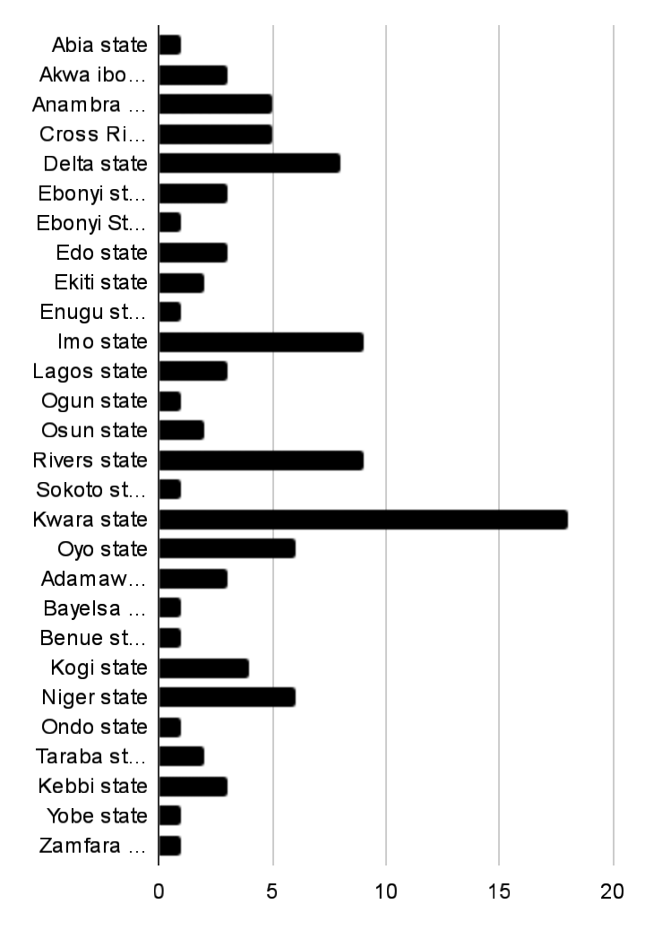

Figure 2: showing the break down of wamako camp corp members population based on their Geopolitical zones.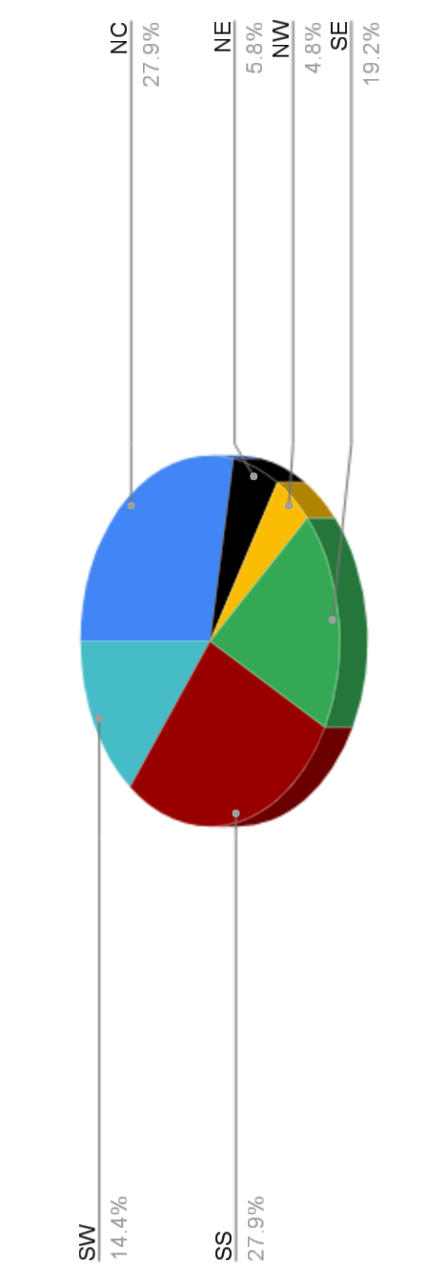

NYSC is really an avenue to meet and interact with insightful minds, minds filled with value and youthfulness, the scheme aims at sensitizing the youthful populace on the diversity in culture of Nigeria and to thence forge Unity and possible coexistence between these cultures.

Every year youths travel to various ends of the country in order to serve their country, a scheme which is almost compulsory for every graduate around the country.

So far, the scheme has fairly achieved this objectives but with the very high request for redeployment by corp members there is an obvious message that should be gleaned from this trend.

Figure 3: Shows the fraction of Corp members in camp seeking redeployment.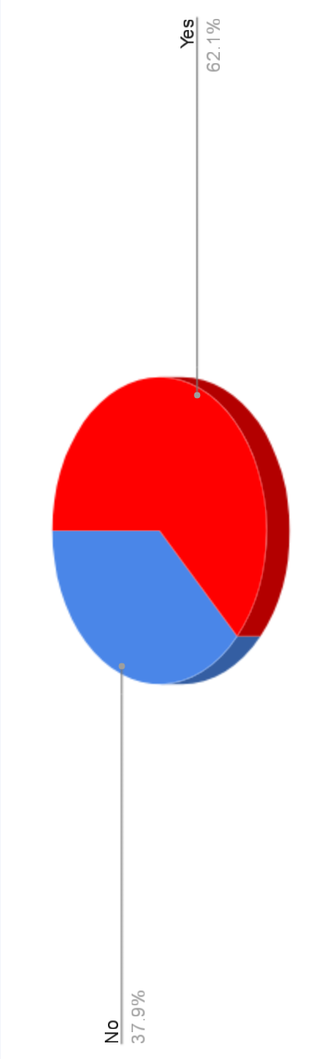

And so I put together 2 of the very reasons (as suggested by my analysis in figure 4 below) more than 60% of Corp members want redeployment so bad.

Figure 4: Showing the reasons Corp members clamour for redeployment.

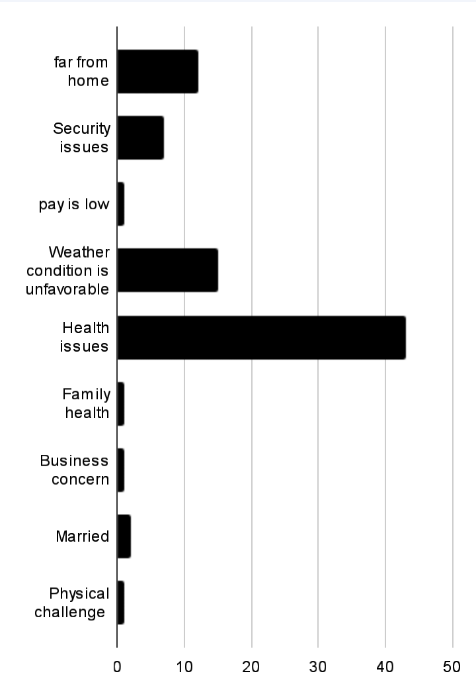

1: Health Conditions: Over 40% of all submitted redeployment forms are based on Health related issues. Corp members with illness such as Asthma, COPD (chronic obstructive pulmonary diseases), Pneumonia, Pulmonary hypertension and so on shouldn't be posted to areas with relatively extreme weather conditions from their residential location especially when the conditions wouldn't be favorable to their health conditions. While those with other health conditions shouldn't be posted to areas far from their residential locations for easy reach to their personal healthcare providers.

2: Weather Conditions: After Health, weather conditions takes preeminence as analysis shows that up to 14% of all redeployment requests are related to it. Corp members often fall ill, collapse, Faint and or fall unconscious during camp activities as a result of extreme heat from the Sun resulting in dehydration, excessive dry and dusty air which resulted in rhinitis and runny nose. at wamako camp issues like this were rampant and this is not far from the fact that the weather conditions are relatively extreme when compared to the residential locations of Corp members being recruited.

**Act**: More so because the above two factors lead the race as cause for the high rate of redeployment requests, I therefore recommend that the NYSC committee in charge for posting corp members take this into consideration when sending corp members out to various locations otherwise they could make provision for materials that could help curb this extreme conditions materials like Cardigans, Nose masks, free, clean and accessible water positioned especially at parade grounds.

In conclusion, Health and Weather conditions lead the race as causes for the high rate of redeployment requests and should be paid attention to by the NYSC committee in charge for posting.